4.3 Evaluation Protocols and Metrics
Two protocols are applied to both datasets: 10-fold stratified cross-validation, in which each fold is used once for testing and the results are averaged, and an independent 66%/34% split with a fixed random seed.
Each classifier is reported with accuracy, precision, recall, F1-score and ROC-AUC, together with Kappa; precision, recall and F1 measure the correctness of the positive class, while ROC-AUC measures its ranking. Apriori rules are assessed with support, confidence and lift.
To prevent data leakage, all class-dependent preprocessing—including standardisation, feature selection and resampling—is fitted inside each cross-validation fold by nesting the corresponding filters within the FilteredClassifier or AttributeSelectedClassifier, rather than being applied once to the entire dataset before validation.

4.4 Weka Tools Configuration
In the Explorer, the preprocessed Mushroom subset (5,644 instances) and raw Ionosphere data (351) are loaded; J48 and RandomForest are trained directly, while Logistic and SMO for Ionosphere are wrapped in a FilteredClassifier with Standardize, and feature selection uses AttributeSelectedClassifier, all fitted within each fold. Apriori is run on Mushroom after removing the class.
The Experimenter is used to produce a reproducible cross-model and cross-dataset comparison. Under the Setup panel, both datasets and the four classifiers (J48, RandomForest, Logistic and SMO) are configured with 10-fold cross-validation, and the results are analysed with the paired corrected t-tester at a significance level of 0.05. All random seeds are fixed to 1, and the output is saved to guarantee that the experiments can be reproduced.

5 Tasks Performed

5.1 Concrete Tasks
1.Ran 10-fold cross-validation and a 66%/34% split on both datasets, computing accuracy, precision, recall, F1, ROC-AUC and Kappa.2.Built the cross-model, cross-dataset comparison in the Experimenter with the paired corrected t-test (0.05).3.Checked for data leakage (fold-nested preprocessing) and wrote the cross-dataset comparison.

6 Results and Analysis

6.1 Quantitative Results
Table 6.1 summarises the main 10-fold cross-validation results for both datasets, reporting accuracy, Kappa and the positive-class precision, recall, F1-score and ROC-AUC. The positive class is poisonous (p) for Mushroom and bad radar return (b) for Ionosphere.
Table 6.1 Main 10-fold cross-validation results
Dataset | Model | Accuracy (%) | Kappa | Precision | Recall | F1 | ROC-AUC
Mushroom | J48 | 100.00 | 1.000 | 1.000 | 1.000 | 1.000 | 1.000
Mushroom | Random Forest | 100.00 | 1.000 | 1.000 | 1.000 | 1.000 | 1.000
Mushroom | Logistic | 100.00 | 1.000 | 1.000 | 1.000 | 1.000 | 1.000
Mushroom | SMO | 100.00 | 1.000 | 1.000 | 1.000 | 1.000 | 1.000
Ionosphere | J48 | 91.45 | 0.810 | 0.929 | 0.825 | 0.874 | 0.892
Ionosphere | Random Forest | 92.88 | 0.843 | 0.932 | 0.865 | 0.897 | 0.979
Ionosphere | Logistic | 88.89 | 0.753 | 0.885 | 0.794 | 0.837 | 0.870
Ionosphere | SMO | 88.32 | 0.735 | 0.921 | 0.738 | 0.819 | 0.866

The independent 66%/34% split gives the same ranking, as shown in Table 6.2.
Dataset | Model | Accuracy (%) | Kappa | ROC-AUC
Mushroom | J48 / RandomForest / Logistic / SMO | 100.00 | 1.000 | 1.000
Ionosphere | J48 | 84.87 | 0.690 | 0.860
Ionosphere | RandomForest | 91.60 | 0.829 | 0.977
Ionosphere | Logistic | 81.51 | 0.623 | 0.801
Ionosphere | SMO | 82.35 | 0.634 | 0.838

On Mushroom, all four classifiers reach perfect accuracy and a Kappa of 1.00 under both protocols, with empty off-diagonal cells in the confusion matrix (3,488 edible and 2,156 poisonous instances correctly separated). On Ionosphere, the scores are lower and vary across models: RandomForest attains the highest accuracy (92.88%) and by far the highest ROC-AUC (0.979), followed by J48, while Logistic and SMO lag behind.
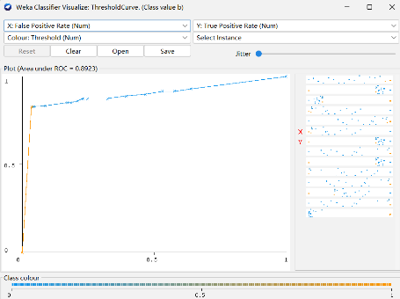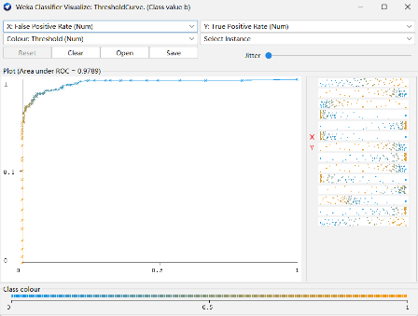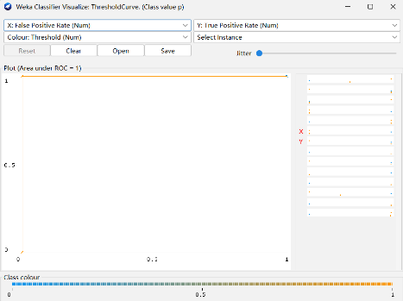
Ionosphere, RandomForest (AUC = 0.979) Ionosphere, J48 (AUC = 0.892) Mushroom, J48 (AUC = 1.00)

6.2 Comparative Analysis of Models and Hyperparameters
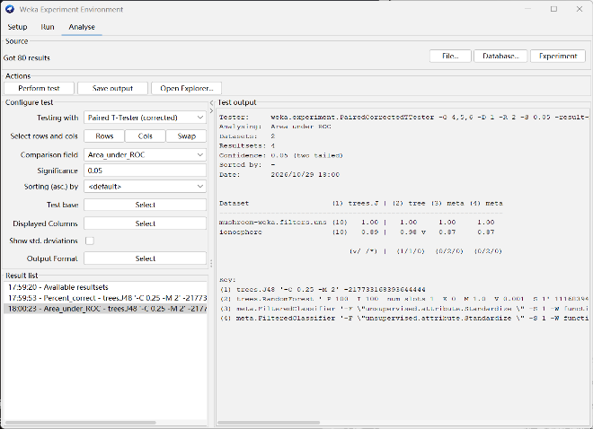
The four models were compared statistically in the Experimenter using the paired corrected t-tester at a 0.05 significance level over the ten folds. In terms of accuracy on Ionosphere, no classifier differs significantly from the baseline J48 (the win/draw/loss counts are 0/2/0 for RandomForest, Logistic and SMO).
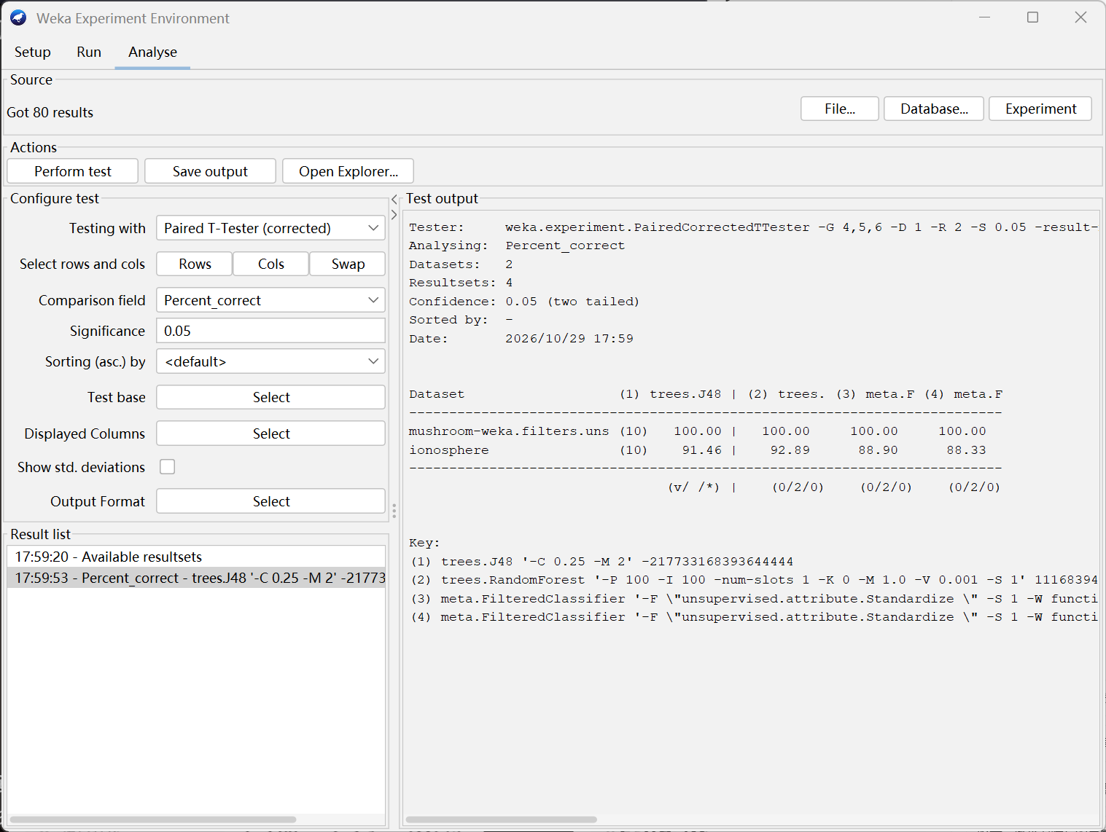
Accuracy comparison ROC-AUC comparison
For ROC-AUC, however, RandomForest records a win/draw/loss count of 1/1/0 and is significantly better than J48, whereas Logistic and SMO are not. Thus the main advantage of RandomForest is not a large gain in the number of correct predictions, but a much more reliable ranking of the positive class, which is valuable when the decision threshold may vary.
The preprocessing choice had little effect on Mushroom: three ways of handling the missing stalk-root values (retaining, removing, and ReplaceMissingValues) all gave 100% accuracy with J48. Two further checks also showed no stable gain: in-fold feature selection (CfsSubsetEval + BestFirst) did not improve J48, and varying the number of RandomForest trees (50, 100, 200) left the scores essentially unchanged (Ionosphere about 93%).
Apriori was also run on Mushroom without the class, producing 20 rules at minimum support 0.80 and confidence 0.90. The rules have lift close to 1 (e.g. ring-number=o → gill-attachment=f, 97.24% support, 100% confidence), so they reflect frequent co-occurrence rather than strong or class-predicting associations.
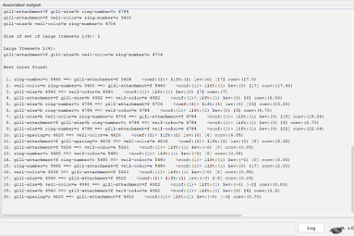
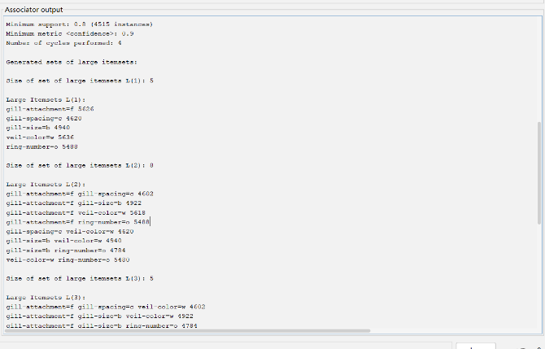
Apriori settings Apriori rules

6.3 Cross-Dataset Comparison
The two datasets produce sharply contrasting results, which reflects their structure rather than the choice of algorithm. Mushroom consists of nominal attributes and is highly separable: a small number of attribute values, such as odour and spore-print colour, determine the class almost deterministically, so even a single J48 tree achieves perfect separation and every model saturates at 100%. Ionosphere, in contrast, consists of continuous radar measurements in which the two classes overlap and some noise is present, so no model reaches perfect accuracy and the scores spread over roughly five percentage points.

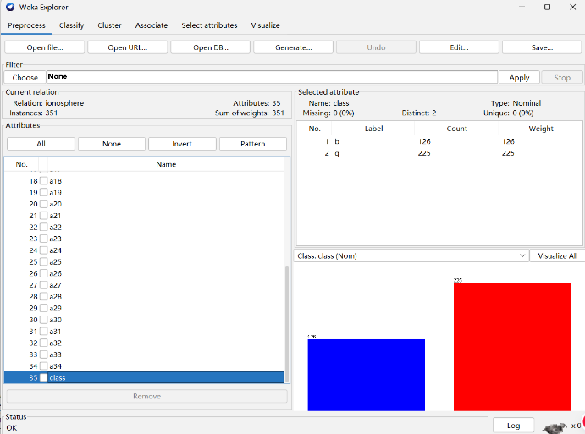
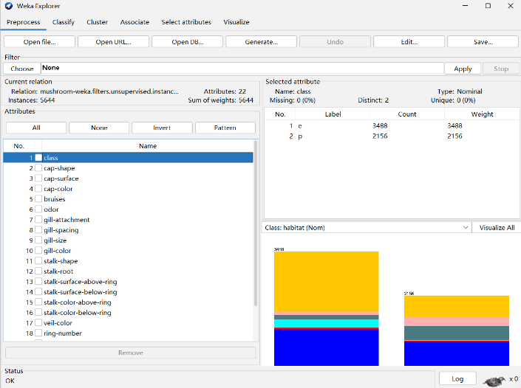
Mushroom (5,644 instances) Ionosphere (351 instances)

The relative behaviour of the models also differs across datasets. On Mushroom the model family is irrelevant, because the problem is easy enough for all four learners; on Ionosphere the ensemble RandomForest benefits from averaging many randomised trees, achieving the highest accuracy and a significantly higher ROC-AUC, while the linear Logistic and SMO models are more constrained by the overlapping distribution. Overall, the cross-dataset comparison shows that the added complexity of an ensemble learner pays off only on the noisier, continuous dataset, while it offers no measurable benefit on the already-separable nominal dataset.

7 Discussion

7.1 Key Findings and Insights
RandomForest performed best on the harder Ionosphere dataset, with a significantly higher ROC-AUC (0.98) than J48, while all four models reached perfect accuracy on Mushroom. Neither feature selection nor more trees gave a stable improvement, showing that added complexity helps only on the noisier, continuous dataset.

